// DEEPIKA SHARMA -124959

- Write a query which displays Staff Name, Department Code, Department Name, and Salary for all staff who earns more than 20000.
Ans. Refer Table: Staff_Master and Department_Master
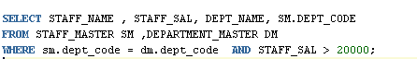
OUTPUT:
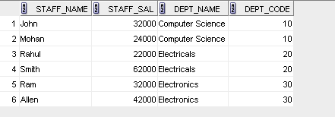
- Write a query to display Staff Name, Department Code, and Department Name for all staff who do not work in Department code 10 and have ‘A’ in their name.
Ans. Refer Table: Staff_Master and Department_Master
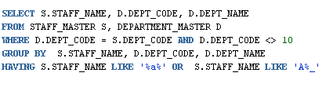
OUTPUT:
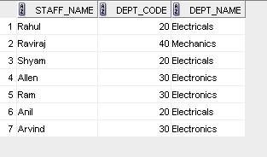
- Display Staff Code, Staff Name, Department Name, and his manager’s number and name. Label the columns Staff#, Staff, Mgr#, Manager.
Ans. Refer Table: Staff_Master and Department_Master and EMP
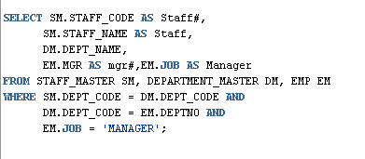
OUTPUT:
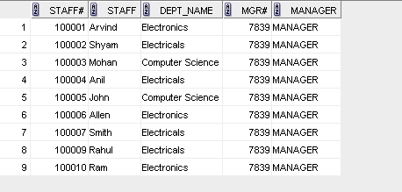

- Create a query that will display Student Code, Student Name, Department Name, Subjec1, Subject2, and Subject3 for all students who are getting 60 and above in each subject from department 10 and 20.
Ans. Refer Table: Student_Master and Department_Master and Student_Marks
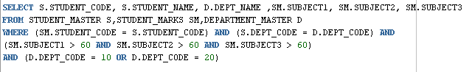
OUTPUT:
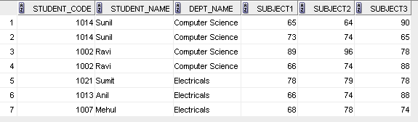
- Create a query that will display Student Code, Student Name, Book Code, and Book Name for all students whose expected book return date is today.
Ans. Refer Table: Student_Master and Book_Master and Book_Transactions
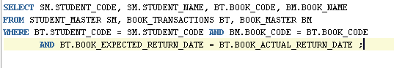
OUTPUT:
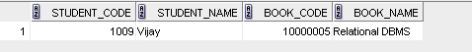

- Create a query that will display Staff Code, Staff Name, Department Name, Designation, Book Code, Book Name, and Issue Date. For only those staff who have taken any book in last 30 days.
Ans. Refer Table: Staff_Master ,Book_Master , Book_Transactions,Department_Master
Designation_Master

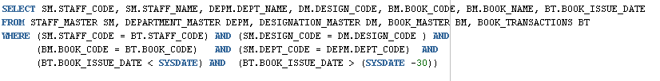
OUTPUT:
NO DATA FOUND

- Generate a report which contains the following information.
Staff Code Staff Name Designation Department Name Department Head
For all staff excluding HOD (List should not contain the details of Department head).
Ans. Refer Table: Staff_Master , Department_Master, Designation_Master
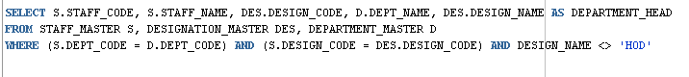
OUTPUT:
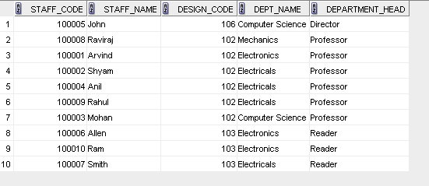
- Generate a report which contains the following information
Student Code Student Name Department Name Total Marks HOD Name
Sort the output on Department Name and Total Marks.
Ans. Refer Table: Staff_Master , Department_Master, Designation_Master,Student_Master
Student_Marks
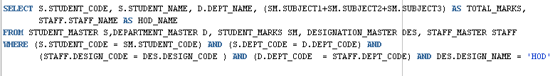
OUTPUT;
NO DATA FOUND

- Generate a report which contains the following information.
Staff Code, Staff Name, Designation, Department, Book Code, Book Name,
Author, Fine
For the staff who have not return the book. Fine will be calculated as Rs. 5 per day.
Fine = 5 * (No. of days = Current Date – Expected return date).
Ans. Refer Table: Staff_Master ,Book_Master , Book_Transactions,Department_Master
Designation_Master
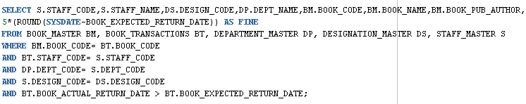
OUTPUT:
- List Staff Code, Staff Name, and Salary for those who are getting less than the average salary of organization.
Ans. Refer Table: Staff_Master
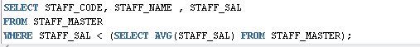
OUTPUT:
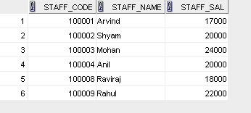
- List the Staff Code, Staff Name who are not Manager.
Ans. Refer Table: Staff_Master,EMP
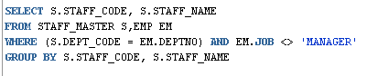
OUTPUT:
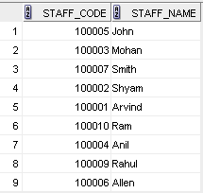
- Display Author Name, Book Name for those authors who wrote more than one book.
Ans. Refer Table: Book_Master
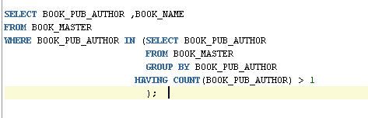
OUTPUT:
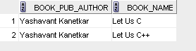

- Display Staff Code, Staff Name, and Department Name for those who have taken more than one book.
Ans. Refer Table: Book_Transaction,Staff_Master,Department_master
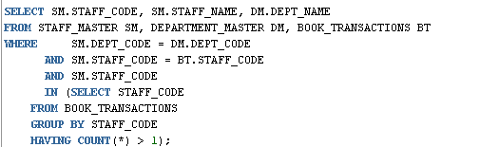
OUTPUT:
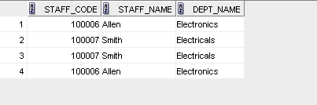
- Display top ten students for a specified department. Details are: Student Code, Student Name, Department Name, Subject1, Subject2, Subject3, Total.
Ans. Refer Table: Student_Marks,Student_Master,Department_master
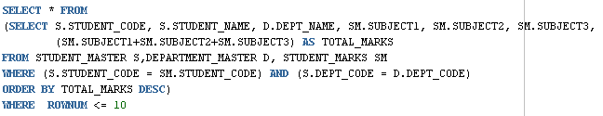
OUTPUT:
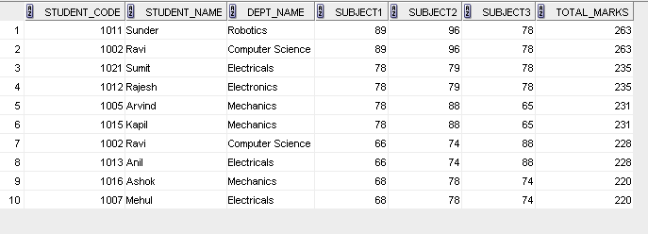
- Display the Staff Name, Department Name, and Salary for those staff who are getting less than average salary in their own department
Ans. Refer Table: Staff_Master,Department_Master
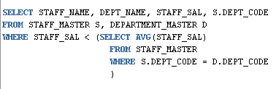
OUTPUT:
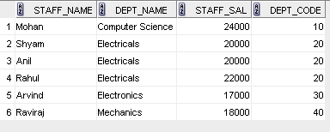
- Create a query that will display the Staff Name, Department Name, and all the staff that work in the same department as a given staff. Give the column as appropriate label.
Ans. Refer Table: Staff_Master,Department_Master
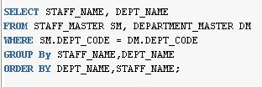
OUTPUT:
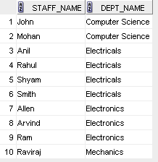
- List the Student Code, Student Name for that student who got highest marks in all three subjects in Computer Science department for current year.
- Display the Student Code, Student Name, and Department Name for that department in which there are maximum number of student are studying.
- Display Staff Code, Staff Name, Department Name, and Designation for those who have joined most recently.
Ans. Refer Table: Staff_Master,Department_Master,Designation_Master
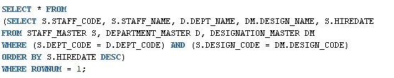
OUTPUT:
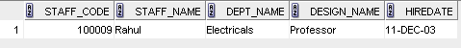
- Display the Manager Name and the total strength of his/her team.
Ans. Refer Table: EMP
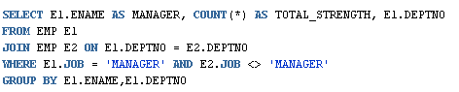
OUTPUT:
